Project 2A: Document Summarization Pipeline using Azure AI Foundry

1. Objective
The objective of this project is to build a scalable AI-based document summarization pipeline that processes PDF documents and generates concise summaries at three levels (short, medium, long). The system also evaluates summary quality using readability and semantic consistency metrics.

Architecture Diagram:

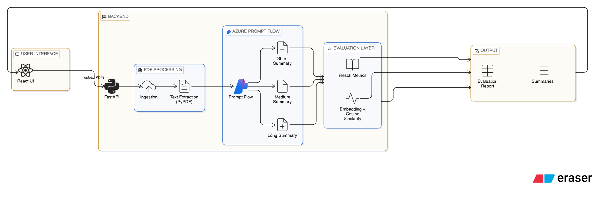

Flow:

User (React UI)
↓
Upload Single / Multiple PDFs
↓
Click "Summarize"
↓
Backend(FastAPI)
↓
PDF Ingestion & Text Extraction (PyPDF)
↓
Azure AI Foundry Prompt Flow
↓
Generate:
Short Summary
Medium Summary
Long Summary
↓
Evaluation Layer(Backend)
- Readability(Flesch Metrics)
- Consistency(Embedding + Cosine Similarity)
↓
Response
↓
UI Displays:
- Summaries
- Evaluation Report Table
1️⃣ User (React UI)
The user interacts with the web interface built using React.
- Uploads one or multiple PDF files.
- Clicks the “Summarize” button.
This is the presentation layer of the system.

2️⃣ Backend (FastAPI)
When the user clicks summarize:
- React sends a POST request to the FastAPI backend.
- The backend receives the uploaded PDF files.
This layer acts as the orchestrator of the pipeline.

3️⃣ PDF Ingestion & Text Extraction (PyPDF)
The backend:
- Uses PyPDF to read each PDF file.
- Extracts text page-by-page.
- Combines all extracted text into a single string.
This completes the document ingestion pipeline.

4️⃣ Azure AI Foundry – Prompt Flow
The extracted text is sent to the deployed Azure Prompt Flow endpoint.
Inside Prompt Flow:
- The input type is string.
- The flow contains three LLM nodes using GPT-4.1:
  - Short Summary node
  - Medium Summary node
  - Long Summary node
The model generates three summaries based on different length requirements.
This is the AI processing layer.

5️⃣ Evaluation Layer (Backend)
After receiving the summaries, the backend performs quality evaluation.
📖 Readability
Using Flesch-based metrics (via textstat):
- Flesch Reading Ease
- Flesch-Kincaid Grade Level
- Average Sentence Length
Purpose:
Measure how easy the summary is to understand.

🔗 Consistency
Using:
- SentenceTransformer embeddings
- Cosine similarity
Process:
- Generate embedding for original document.
- Generate embedding for summary.
- Compute similarity score (0–1).
Purpose:
Measure semantic alignment between summary and original content.

6️⃣ Response
The backend prepares a structured response containing:
- Short summary
- Medium summary
- Long summary
- Evaluation metrics

7️⃣ UI Display
The React UI displays:
- All three summaries
- Evaluation report table

